**OUTREACH NOTICE**

**Region 4**

**Humboldt-Toiyabe National Forest**

**Bridgeport Ranger District**

**GS-0454-5/7/9 Rangeland Management Specialist**

The Bridgeport Ranger District is currently outreaching for one permanent full-time GS-0454-5/7/9 Rangeland Management Specialist position with a duty station of Bridgeport, CA. Depending on the outreach response, referral lists will be considered in both the Merit and Demo categories. All interested applicants should submit the attached outreach survey form so they can be notified of the vacancy announcement number and closing date when it becomes available. SCEP students looking for placement/conversion are encouraged to apply.

**Position Information**

The successful applicant will assist the Supervisory Rangeland Management Specialist with administering a challenging Range program on the 1.2 million acre Bridgeport Ranger District. The year round grazing program encompasses 56 allotments and 22 permittees. Of the 50 active allotments, 29 are cattle and 21 are sheep. There is approximately 50,500 HM of sheep grazing and 18,500 HM of cattle grazing currently authorized on the district. Eight allotments are located in the Hoover Wilderness.

The District is currently working on an Environmental Impact Statement for 12 allotments and an Environmental Assessment on 3 allotments. We have several allotments with Threatened, Endangered, and Sensitive species habitat. There are two Wild Horse and Burro Territories on the District.

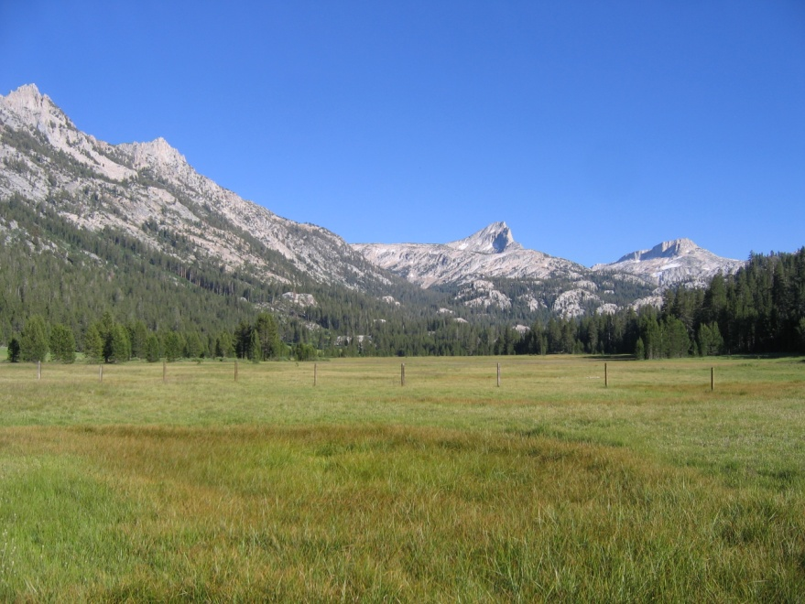The primary duties for this position at the fully functioning GS-09 level include assisting the Supervisory Rangeland Management Specialist with the management of the Rangeland Management, Botany, and Invasive Plant Species programs. Administration of grazing permits includes allotment and pasture inspections, trend and condition monitoring in upland and riparian settings, annual utilization monitoring, and documentation of allotment visits and conversations with permittees. Communication with grazing permittees is a key part of this position. The specialist will record allotment inspections, conversations, and monitoring information for use in decision making. The specialist will cooperatively develop Annual Operating Instructions with permittees for the grazing season. The specialist will provide recommendations on range improvement projects, order materials within budget constraints and ensure the projects are completed to Forest Service standards. The specialist will assist the Supervisory Rangeland Management Specialist with NEPA documents for range projects and other district/forest projects as needed.

Upper Piute Meadow in the Hoover Wilderness

The District Botany Program is vital to the NEPA process for all project work. The incumbent may be conducting botany surveys and monitoring sensitive plant species and habitat, and will assist in writing biological evaluations.

The District has a very small Noxious Weed Program. There are small infestations of perennial pepperweed, whitetop, and a few other species on the district. The largest documented populations are on an old Ranch property, known as Rosaschi Ranch, which was acquired by the Forest Service in 1995. Other populations are mainly located on private land in-holdings.

Attendance at public and agency meetings on a variety of technical and professional topics will be required. Use of an ATV, 4-wheel drive vehicle, and horses will be necessary as a regular part of this job, as will hiking across uneven terrain at high elevations. If the position is hired at a GS-05 or 07 level, the employee will perform these tasks under close supervision until reaching the full GS-09 level.

**About the Bridgeport Ranger District and Humboldt-Toiyabe National Forest**

The Humboldt-Toiyabe National Forest consists of 6.3 million acres and includes ten ranger districts. The Bridgeport Ranger District is located on the west side of the H-T; flanked on the west by the dramatic Sierra Nevada and falling away eastward to the Great Basin Desert. The Bridgeport District encompasses 1.2 million acres and spans 5 mountain ranges. Two-thirds of the district is in Nevada, one-third is in California. The District borders Yosemite National Park and several wilderness areas. Vegetation ranges from high alpine plant communities to salt desert flats.

The District has a robust program of work that covers range, fire and fuels, recreation, wildlife, fisheries, watershed, noxious weeds, minerals and special uses. There are about 30 permanent employees and the District typically hires additional seasonal employees. The District is also home to the US Marine Corps Mountain Warfare Training Center.

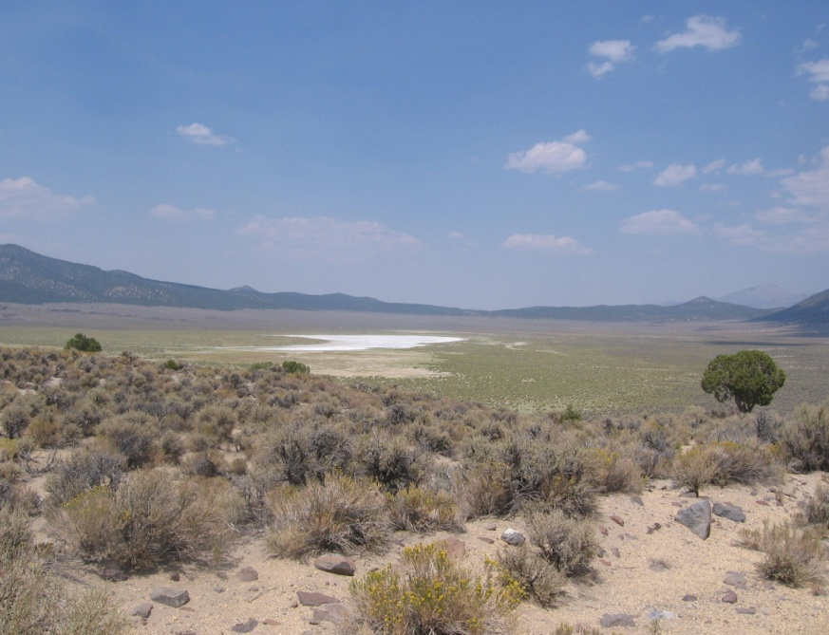**Bridgeport Community Information**

The Ranger Station is located in Bridgeport, CA, a town of about 800 year-round residents, nestled at the base of the Sierra Nevada. In the summer, the area swells with tourists coming to enjoy the scenic beauty and outstanding fishing opportunities. Bridgeport is about 45 minutes from Yosemite National Park, 1 1/2 hours from Lake Tahoe, and 2 1/2 hours from Reno, NV.

Government housing may be available with this opportunity. Housing in Bridgeport is limited. Rentals range from $600 to $1000+ per month. A typical 3 bed/2 bath single family home in Bridgeport costs anywhere from $250,000-$350,000+.

Alkali Lake on the east side of the District

Bridgeport has a K-8 elementary school. High schools are located in Lee Vining, CA and Coleville, CA. Churches representing several denominations can be found within the local commuting area. Bridgeport has a small clinic and ambulance and Life-Flight services. Hospitals are located in Gardnerville, NV and Mammoth Lakes, CA. Bridgeport has a small grocery store and several restaurants/bars.

Annual precipitation in Bridgeport averages 9 inches/year. Total annual snowfall averages 50 inches with most occurring from December to February. Summer highs in Bridgeport rarely reach 90 degrees (F) or above. In winter, low temperatures can reach 30 below zero.

**Contact**

If you are interested in the Bridgeport Rangeland Management Specialist position, contact Rixey Jenkins, Supervisory Rangeland Management Specialist, at 760-932-5850 or [rixeyjenkins@fs.fed.us](mailto:rixeyjenkins@fs.fed.us).

**OUTREACH RESPONSE FORM**

Bridgeport Ranger District

PERSONAL INFORMATION

Name: Date:

Address:

Phone: Email address:

Brief Description of Qualifying Experience:

**Thank you for your interest!**

Please return the Outreach form to Rixey Jenkins, Supervisory Rangeland Management Specialist,

[rixeyjenkins@fs.fed.us](mailto:rixeyjenkins@fs.fed.us).